**Gym:** Thrive Fitness, Monroe, WA ([web](Gym:%20%09Thrive%20Fitness,%20Monroe,%20WA%09(1/10/17))) ()

**Trainer:**  Caitlin

**Fitness Plan**

**Prev (2014):** 183.0 lbs (10%) 164.7 lbs / 18.3 lbs

**Start (1/28):** 177.4 lbs (14.4%) 151.9 lbs / 25.5 lbs

**Today (2/18):** 186.0 lbs (16.4%) 155.5 lbs / 30.5 lbs (+3.6) / ( +5.0)

**Phase Goal:** 191.0 lbs (*) *162.2 lbs* / *28.8 lbs*

**+10 lbs / D.C.**

**Present Phase** – **Beginning to Grow, Round Two**

This phase directly follows the starting phase of weight loss, dropping 35 lbs from 1/15 to 1/17, a phase of stark nutritional restriction and a strong avoidance of growth. That weight-loss mark has been achieved, now it is finally time to grow!

Growth after two years of starvation is a confusing topic, one full of learning, establishing new habits and beginning a new routine. And then add the second dimension, the neurological dimension of my injury recovery, this phase has a strong pre-requisite of preparation, plan and distinct transition out of the last phase!

Put simply this phase is the “Beginnings of Growth”, learning how to grow and following Caitlin’s guidance ☺

Phase Goals

* Stop losing weight! (gaining is secondary, first stop losing!)
* Gain muscle mass (target: 10 lbs, 2 months)
* Grow new habits, transition far away from last phase (habits in diet & routine)

Schedule

* 14 days On (4 day routine plan)
* 1 day Off (rest) (as an option ☺)

Status

* Complete once Phase Two (present) diet is hit, and maintained fully!

**Routine Plan**

Each session will include the following:

* Pre: 3 Pullup holds to drop
* Pre: 10-15 minutes of treadmill (any, just a warmup)
* Post: 15 minutes elliptical
* Post: Completion of the Stretching Routine

**Supplemental Nutrients Plan**

* Protein (pre/post workout) – 3 Scoops w/Almond Milk [Nitro Tech Whey Gold]
* Aminos (pre/post workout) – 1 Scoop
* Water (daily) – 10 bottles daily (carried alongside, at gym, in car and at office)
* Vitamins (daily) – Centrum, Magnesium, Potassium, Vitamin D, Fish Oil

**Training Plan - Round Two**



**Pre-Workout Routine**

**Side Goals**

* Dumbbell Curls (8 reps @35 lb.)
* Two-Mile run in 14 min (7min mile)
* Flat Bench Press (6 reps @ 225 lb.)
* Hanging Inverted Ring Flip (w/Rob)
* Box Jumps
* Correct, Full Leg Lifts (see notes)
* Torso fitness & aesthetic
* 10 min treadmill walk or run
* 15 Hanging Leg Raises

**Post-Workout Routine**

* Sled Push (1x45) – (4) Down & Backs
  + Stay low, long steps
* 15 min elliptical
* Stretching (4 breaths per hold or 10 sec, 4 holds or 30 sec, run sequence each time)
  + Seated Hamstring Stretches
  + Gross-Glute Stretch
  + Hip Flexor Stretch
  + On-Wall Pec Stretch
  + Straight Arm Pulldown
  + Hamstring Back Extension
  + Wide Hamstring Stretch
  + Bent-over Pole Squat Stretch (Bring around, all the way down)
  + Pole Good Mornings (Raised High)
  + Pole behind the back
  + Smith Squats (8-12 reps)

**Plan Goals**

* Short-term: (primary: shape) (secondary: strength)
* Long-term: (primary: fitness) (secondary: shape, strength)

**Central Lift Style Points**

* Always squeeze the shit on grips **during** a lift. Grip strength & muscle activation bloom here!
* Always squeeze on **entry** into a lift and on **exit**. Muscle engagement and activation grow here

**Important Points**

* You should feel **full** when you go into lifting!
* Don’t lift like a body-builder, 3 sets of 10 is dangerous and generally weak in benefit
* Changing lift sets and rep counts is important!
* Power generation, e.g. jumping or throwing is one of the greatest muscle growth activities

**Key & Vocab**

* *Failure*: performing an exercise to complete exhaustion while maintaining perfect form. When your form

breaks, you have failed

**Leg Lift Notes**

* *2*0 in a row, above 90 degrees with legs straight. Place left leg over right to emphasis symmetry!

**Next Phase** – **Increasing Growth**

Phase two (previous phase) was just the start of growth. Now we will begin really growing, full diet, bigger sets, heavier weights!

**Duration**

* 12 Weeks

**Schedule**

* March 1st begin lifting plan
* March 21st begin full plan, diet, etc. – 12 weeks!

**Present Nutrition Plan**

Goal: transition to target plan incrementally, and as quickly as possible!

Important Phase Point: The scale doesn’t matter, adherence to plan does. Weigh yourself every two weeks now.

**Breakfast [6 am]**

* (4) Hardboiled Eggs
* Banana
* (1) Scoop Protein w/Milk
* Greek Yogurt (1 cup)
* Granola (1/3 cup)

**Workout [7 am]**

* (2) Glutamines, pre/post

**Post-Workout [8 am]**

* (2) Scoops Protein Powder
* (1) Scoop Prime Nutrition PWO-MAX
* (1) Scoop Aminos
* 6 oz. Whole Milk

**Snack [10:30 am]**

* (10:30 am) Protein Bar

**Lunch [11 am]**

* (11 am) Tuna Sandwich
* (12 pm) Mass Builder Shake
  + GNC Mass Gainer Complex (2 scoops)
  + 8 oz. Whole Milk
* (1 pm) Tuna Sandwich
* (2 pm) Meal Replacement Shake
  + GNC Total Lean (3 scoops)
  + 8 oz. Whole Milk

**Snacks [3 pm]**

* (3 pm) 32 oz. Nutri-bullet Juicer
  + Apple
  + Banana
  + Blackberries
  + Kale
  + Rolled Oats
  + Cashews
  + Almond Milk
* (2) String Cheeses

**Dinner (8pm)**

* Whatever Mom’s cooking, typically chicken, bread & cooked veggies!

**Target Nutrition Plan**

Transition here incrementally, first step is tuna sandwiches for lunch!

*1 gallon of water/day

**BREAKFAST**

*(Immediately upon waking)*

1 scoop protein powder

1 apple/banana/orange (pick one)

**BREAKFAST 2**

(30-60min after first meal)

4 whole eggs

1 slice low fat cheese

2 pieces Peanut Butter Toast

**SNACK 1**

1 Clif Bar or Protein Bar

2 Stringed Cheeses

**LUNCH**

1 multivitamin

1 can Tuna

1 tbsp light mayonnaise

2 slices bread

(make sandwich)

**PREWORKOUT**

One Large Fruit

**POST-WORKOUT**

2 Scoops Protein Powder

5g Creatine

**DINNER**

7oz. Meat Protein (see food list)

1 Avocado

1c. Steamed Broccoli

**Caitlin’s Plan Guidance Notes**

REINA, PHASE 2, TRAINING

The focus of this plan is to improve **strength,** mobility, functionality, and flexibility. Every session will include a 15min. warm-up, followed by a 10min. stretching routine. Stretching is imperative to improving your functionality and providing your muscles with the recovery they need to grow, TAKE YOUR STRETCHING SERIOUSLY.

During your lifts, you must be focused on chasing the discomfort that comes with growing new muscle. You should never hurt from your training, but your muscles should be SEVERELY fatigued. If you can’t push yourself past exhaustion, your muscles will not learn to adapt to the new stress being applied to them, thus your “gains” will be slower and smaller (we don't want that). In all of your exercises focus on feeling the STRETCH/ACTIVATION/SQUEEZE.

**Opens**

* Read “Born to Run”, recommended by Rob
* Do Prime Nutrition’s Online Learnings
* Research John Meadows
* Read “Zen and the Art of Motorcycle Maintenance”
* Review the House of Falling Waters, by Lloyd S. Wright

**Longer Term Opens**

* Visit a chiropractor, get an evaluation. Setup a periodic visit here, the longer-term benefits are profound!

**Notes**

* Most of your current weight bump is water and food retention
* You want a slow releasing vitamin, Centrum is not this!

**Appendix A - Past Stages and Goals**

Stage (1/16 – 1/17): Weight Loss

Lost about 30 lbs (210 -> 177), with the end target the whole time of 177 lbs or 13% BF, whichever came first ;)

Goal (start: 1/16, hit: 1/17)

Do One Pull-up

**Appendix B – TDEE, Total Daily Expenditure Estimate**

How much energy your body expends in a day, in caloric expression. Stated simply, the calories your body needs in a given day.

TDEE Factors

* Body Physique
* Level of Physical Activity
* Dietary Intake
* Genetics

TDEE Components

* (80%) Basal Metabolic Rate
  + Resting (core body components, like lungs & liver) (70%)
  + Thermo-genesis, the thermic effect of food (10%)
* (20%) Activity Energy Expenditure (wide range)

TDEE Effects

* Height: Up
* Weight: Up
* Age: Down

There are plenty of online calculators and you should use this tooling to establish your state, in different levels (normal, weight-loss, muscle gain).

Justin Calc (12/23/16, 5’11”, 180 lbs., Heavy Exercise 6-7 days/wk, 90 min exercise/day)

[SailRabbit](http://www.sailrabbit.com/bmr/) (2133 calories per day - for losing 1lb per week)

[MuscleForLife](https://www.muscleforlife.com/tdee-calculator/) (2715 calories per day)

[TDEECalculator](https://tdeecalculator.net/result.php?s=imperial&g=male&age=31&lbs=180&in=70&act=1.725&f=1) (3067 calories per day)

[MyTDEE](http://mytdee.com/#gender=male&yr=31&cm=177.8&kg=81.6&bfp=15&goal=lose&goal_kg=80.3&lose_speed=recommended&formula=bfp&units=imperial&exercise=very) (2578 calories per day - recommended), (1934 calories per day - reckless)

[Fitness Frog](http://www.fitnessfrog.com/calculators/tdee-calculator.html) (3217 calories per day)

My Personal Conclusion (for current 7 days/wk lifting plan)

(3200 calories per day – moderate weight gain (1.0 lbs / month muscle)

(1900 calories per day - short-term reckless weight loss (1.5 months max)

(2200 calories per day - minimum weight loss general (no limits)

(3100 calories per day - general sustain level) (no limits)

**Appendix C – Losing Fat is not Losing Weight!** ([How To Lose Fat Without Losing Muscle – Burn Fat, NOT Muscle](http://www.aworkoutroutine.com/how-to-lose-fat-without-losing-muscle/))

People often say they want to lose weight, meaning they want to be in better shape, and to look better. This in essence means losing fat not weight, dropping the body fat percentage and increasing the muscle mass. This is not aligned with “weight” loss at all, which includes all of you (water, glycogen, muscle, fat, etc!). Well can you lose your muscle mass while only trying to lose body fat? Heck yes, but this takes focused, consistent effort and intent, and this takes time.

The primary and perhaps semi-apparent component then of fat loss is caloric deficit, consuming less than your body needs to perform its tasks for the day. It is important to note then, as described earlier, that simply minimizing this consumption is only the first step. See it turns out your body kind of doesn’t give a shit about what it burns to survive, it burns what is available, and what works given the current conditions and state. And here then is your key.

**Your key is to maximally align and prepare your bodie’s condition, diet and activities for it to then burn fat, while maintaining muscle.**

Here are some keys to this goal.

1. **Eat enough Protein**

* A sufficient daily protein intake is the single most important dietary requirement for maintaining muscle

1. **Maintain Strength/Intensity/Weight On The Bar**

* the primary training stimulus required for maintaining muscle is maintaining your current levels of strength
* On a fat loss diet just maintaining your current levels of strength (aka intensity, aka the weight on the bar) is what now signals your body to maintain muscle
* If that signal goes away, your body’s need to keep your pretty muscle tissue around goes away right along with it
  + That’s why the insanely stupid myth of lifting heavier weights to build muscle but then lifting lighter weights (for higher reps) when you want to lose fat, get lean and get toned is the absolute WORST thing you could possibly believe when you’re trying to avoid losing muscle
  + In reality, you lift heavy weight to build muscle, and then lift that same heavy weight if you want to actually maintain that muscle
* Sure you can continue trying to get stronger and continue trying to make progressive overload happen while losing fat. It can and does happen (especially for beginners, who should still be progressing consistently even in a deficit)

1. **Reduce Weight Training Volume and/or Frequency**

* A caloric deficit is really an energy deficit, and while this is fantastic (and required) for losing any amount of body fat, it eliminates energy for the rest of your time and life
* If not reduced, this regimine can actually lead to strength loss (lifting a lot with insufficient energy available!)

1. **Get Pre & Post Workout Nutrition Right… Still**

* Pre and Post workout nutrition is centered on the maximization of effect in training and recovery from training periods, which is directly aligned with your weight loss plan's point of excercize - maximizing effect of this time spent!

1. **Don’t Reduce Calories By TOO Much**

* A moderate deficit of about 20% below maintenance level is what ends up being most ideal in most cases
* Reducing your calorie intake by TOO much will increase the potential for strength and muscle loss

1. **Avoid Excessive Amounts Of Cardio (Or Just Don’t Do ANY At All)**

**Appendix D – A Challenge**

8% by July 2017, game on -

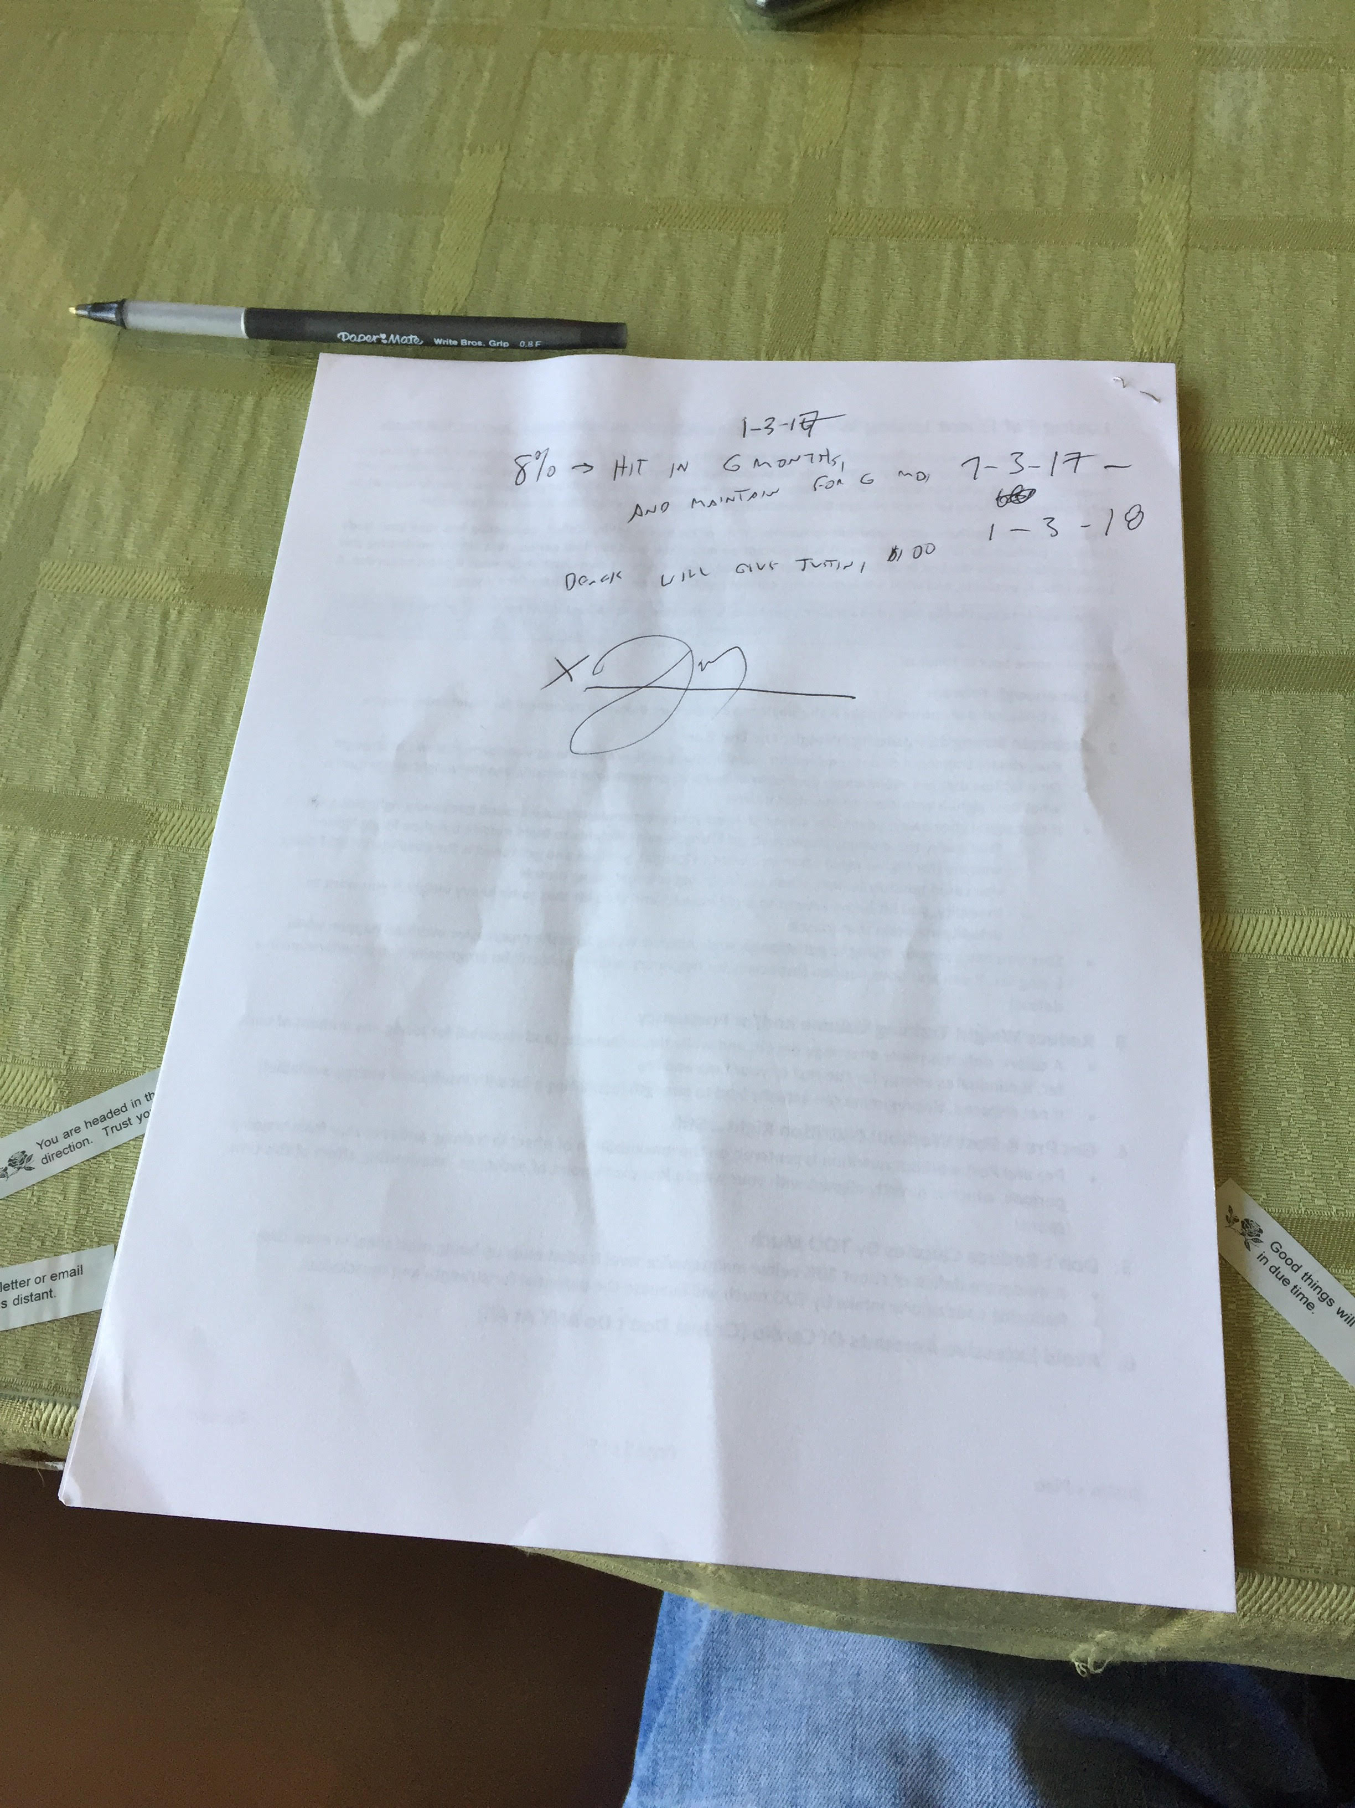

This means 7% body fat loss, 14 pounds in six months, or 14 pounds in 3 months for reasonable estimation.

14 lbs / 12 weeks -> 1.2 lbs / week

I have been at the pace of 1 pound per week for the past month, this appears quite achievable!